Interdisciplinary linguistics: Challenges and rewards
With linguistics becoming ever more interdisciplinary, linguists often find themselves in departments (Composition, English, Languages) with colleagues who, though possibly supportive of linguistics, share little expertise in the field. Here we share our experience as linguists in an English department, to illustrate the rewards of integrating linguistics into the undergraduate curriculum. We outline how this experience, and similar experiences of colleagues in other departments, has changed – in positive ways – what it means to teach and do linguistics.

These interdisciplinary experiences and the opportunities they provide also raise challenges for the field that have yet to be met.

How does the interdisciplinarity of linguistics change what it means to teach and do linguistics?
- How does it expand opportunities for teaching, research and service?
- How do we meet the needs of both majors and non-majors?
- How do we prepare new PhDs for interdisciplinary positions?
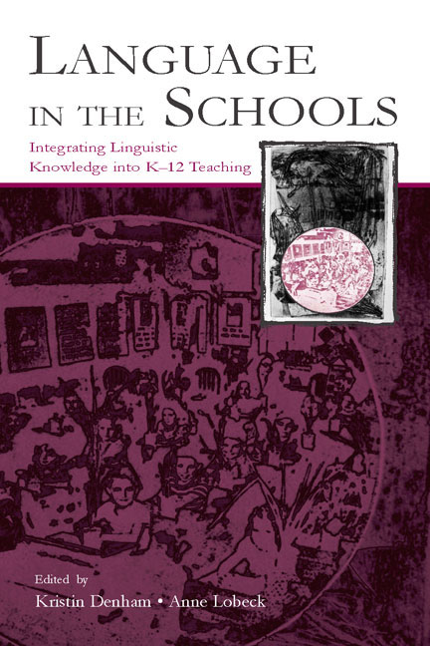
Linguistics in an English Department: Our experience
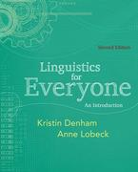
We were originally hired in the English department as the result of an accreditation review, a review that mandated that the department include (some version of) the study of English language, particularly as part of the English Education major. Since then, the Introduction to Language we have developed has become a requirement for all English majors. We have also developed a series of upper division courses in language and linguistics over the years, including The Structure of English, The Cultural History of English, Linguistics for Teachers, as well as a general education course for non-majors, Language and Society: American Dialects. We recently succeeded in developing a minor in English Language and Linguistics for English majors who do not major in Linguistics, but who have a clear interest and investment in the study of language within the English major. This minor includes courses from the university’s interdepartmental Linguistics Program, of which we are also a part, teaching (between us) three courses in syntactic theory a year. (Our teaching and curriculum development in the Linguistics Program is another, related story, which we leave aside here, but which also forms part of our larger experience as linguists teaching undergraduates in a middle-sized state university.)

Teaching English majors, including future teachers, as well as non-majors and Linguistics majors has enriched our professional lives in terms of research, teaching, and service to the community and the profession in ways we would never have considered after graduate school, where we were both steeped in research on theoretical syntax. Far from requiring us to abandon “real” linguistics, we discovered a uniquely rewarding opportunity to incorporate linguistic inquiry into K-12 education. This work has led to partnerships with K-12 teachers, which have led to internal and external grants and publications.

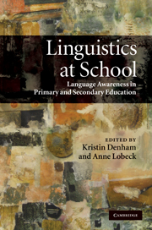
Our partnerships began with observation, evolved into small-scale collaboration, then into larger scale curriculum development (Pippin and Denham 2012, Lobeck and Smith, in progress). The insights we’ve gained about how to make linguistics relevant and accessible to K-12 teachers and students have also changed the way that we teach introductory linguistics to our undergraduates. Rather than “dumbing down” the course materials to make them more accessible, we have increased the focus on scientific methodology, inspired by collaborative work with Maya Honda and Wayne O’Neil (Honda 1994; Honda, O’Neil, and Pippin 2010). Such work offers new opportunities to redefine and invent ways to be linguists, ways to teach linguistics, and ways to support each other and our students.

Other Successful Experiences and Models
Our interdisciplinary experience allows us to directly connect teaching, research and service in diverse and productive ways. But our experience is simply one example of many successful interdisciplinary and community connections (which are not necessarily focused on linguistics and education). Other examples include:
- Jeffrey Reaser and Walt Wolfram’s projects in North Carolina (2007)
- Tom Purnell, Eric Raimy, and Joe Salmons’ community outreach project in Wisconsin (2013)
- Maya Honda and Wayne O’Neil’s work with teachers (1993, 2010)
and others
Teaching linguistics (and Teaching Linguistics) is not just about teaching linguistics to linguistics majors, but teaching the science of language to a much wider range of students and involving the community in a variety of ways. The thread that connects all of these projects – and that we cannot lose sight of – is the importance of a focus on scientific methodology and scientific inquiry across all levels (K-12, undergraduate, graduate). This kind of outreach beyond the ‘disciplinary tent’ of linguistics (in Mark Liberman’s words) has important ramifications not only for those we teach, but also for our own careers, providing linguists with new and important ways to teach and do linguistics.

Looking Ahead: Some next steps
What are some next steps in strengthening and facilitating the reach of linguistics beyond its traditional disciplinary borders, to engage students and the community?

- Develop linguistics curricula for majors and non-majors that encourage real life connections with the community;
- Develop graduate courses and tracks that support these connections (linguistics and education; heritage language and dialect study; language revitalization, etc);
- Develop K-12 curricula and materials to close the loop between linguistics in higher education and K-12 teaching about language;
- Educate the public and colleagues on the value of this work and its importance to teaching, research, and service.

The new online theme of Language, Teaching Linguistics, and Wiley-Blackwell’s Language and Linguistics Compass: Education and Pedagogy encourage discussion of these topics and are examples themselves of the changing focus of teaching and doing linguistics.

Selected References
Denham, Kristin and Anne Lobeck (2010, 2013, 2nd ed) Linguistics for Everyone: An Introduction. Boston: Cengage/Wadsworth.
Denham, Kristin and Anne Lobeck, eds. (2005) Language in the Schools: Integrating Linguistics into K-12 Education. Mahwah, NJ: Lawrence Erlbaum Associates.
Denham, Kristin and Anne Lobeck, eds. (2010) Linguistics at School: Language Awareness in Primary and Second Education. Cambridge University Press.
Honda, Maya. (1994). Linguistic Inquiry in the Science Classroom: "It is science, but it's not like a science problem in a book." MIT Occasional Papers in Linguistics, No. 6. Cambridge, MA: MIT Working Papers in Linguistics.
Honda, M. and W. O’Neil (1993)‘Triggering science-forming capacity through linguistic inquiry,’ In The view from Building 2: Essays in linguistics in honor of Sylvain Bromberger, K. Hale and S. J. Keyser (eds.), 229-255. Cambridge MA: The MIT Press.
Honda, M., O'Neil, W., & Pippin, D. (2010). On promoting linguistics literacy. In K. Denham & A. Lobeck, Linguistics at school: Language awareness in primary and secondary education (pp. 175-188). Cambridge, England: Cambridge University Press.
Lobeck, Anne and Kristin Denham (2013) Navigating English Grammar: A guide to analyzing real language. Boston: Blackwell Publishing.
Lobeck, Anne and Dana Smith (in progress). Teaching Grammar Through Inquiry. High school curriculum and teachers’ guide.
Pippin, David and Kristin Denham (2012) Voices of the Pacific Northwest. Draft manuscript for middle school social studies curriculum.
Reaser, Jeffrey, and Walt Wolfram (2007, previous version 2005). Voices of North Carolina: Language and Life from the Atlantic to the Appalachians (second edition). Teachers’ manual, student workbook, and resource DVDs. [NC DPI endorsed](http://www.ncsu.edu/linguistics/education/dialectcurriculum.php)
Purnell, Tom, Eric Raimy and Joe Salmons (eds.) 2013. Wisconsin Talk: Linguistic diversity in the Badger State, Madison: University of Wisconsin Press.

